EXPERIMENT 6: Champagne Tower

Aim:
To write a Python program to simulate the Champagne Tower and determine the amount of champagne present in a particular glass using dynamic programming.

Algorithm:
- Start.
- Define the amount of champagne poured.
- Define the required row and glass position.
- Store the amount of champagne present in each glass.
- Pour champagne into the top glass.
- If a glass contains more than 1 unit, the extra champagne flows equally into the two glasses below it.
- Repeat the process for all rows up to the required row.
- Find the amount of champagne in the specified glass.
- If the amount is greater than 1, return 1 because a glass can hold only 1 unit.
- Display the result.
- Stop.

Source Code:

def champagne_tower():
print(" 1")
print(" / \\")
print(" 2 2")
print(" / \\ / \\")
print(" 3 3 3 3")

print("CHAMPAGNE TOWER\n")
champagne_tower()

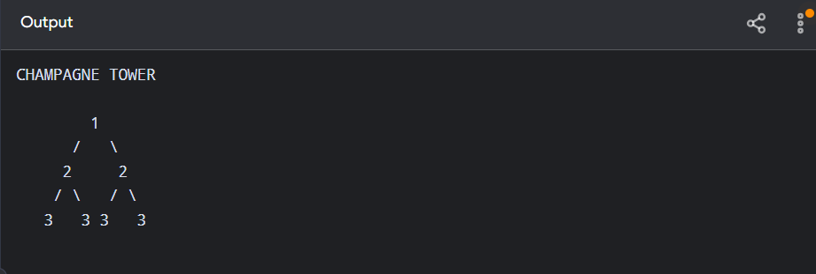

Result:
Thus, the Champagne Tower problem was successfully implemented using dynamic programming, and the amount of champagne present in the specified glass was determined.

